21.09.2021
«Семья. Настоящее время»
Лекция на тему «Present Simple (простое настоящее время)»
Present Simple – простое настоящее время в английском языке. Оно выражает действие, которое происходит в настоящем времени или регулярно. Также оно используется для выражения действия без указания определенного времени:
- I work at home.
- Bakery is a good business.
- Jill speaks four languages fluently.
- On Sundays, we like to fish.

Как образуется Present Simple?
Present Simple образуется очень просто: убираем у глагола в инфинитиве частицу to и ставим его на второе место в предложении, после подлежащего. Для третьего лица (“he,” “she,” “it”), добавляем глаголу окончание “—s“, “—es“, если глагол оканчивается на гласную, или “—ies“, если глагол заканчивается на ” y” (to try“, “to cry“):
To work
- I work
- you work
- he / she / it works
- we work
- they work

Есть и исключения, например, глагол To be:

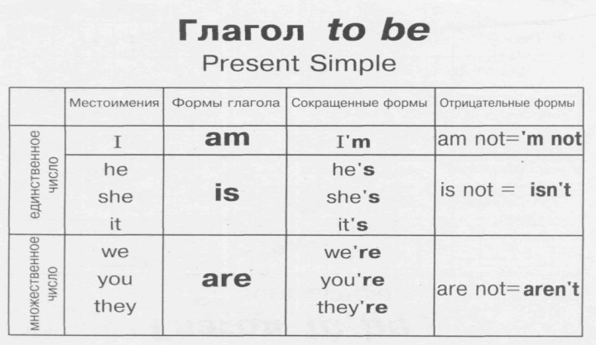
- I am
- you are
- he / she/ it is
- we are
- they are

  - Прочитайте и переведите текст.

My family.

My name is Ilya. I am ten. I go to school. I am a good pupil because I always do my homework and get exсellуnt marks.
I have got a family. It is big and friendly. There are four members in my family. They are my mum, dad, brother and me.
I have got a mum. Her name is Lena. She is thirty-five. My mum is clever and kind. She is a housewife. My mum is good at cooking. Every day she cleans the rooms, washes the dishes and doesn`t let my brother and me fight.
I have got a father. His name is Dima. My father is handsome and serious. He is very busy and works a lot. My father is fond of playing computer games.At the weekends we play games together. Also, he helps me with my homework and my mum with housework. He is the best dad in the world!
My younger brother is two. His name is Vanya. He looks like my dad. Vanya is strong, clever and talented. He can swim and run. Vanya likes watching cartoons on TV.
I love my family. I am happy!

  - Вставьте глагол “to be” в требуемой форме Present Simple.

- I ... a student.
2. My father ... not a shop-assistant, he ... a scientist.
3. ... your aunt a nurse? - Yes, she ... .
4. ... they at home? - No, they ... not. They ... at school.
5. ... you an engineer? - Yes, I....
6. ... your friend a photographer? No, she ... not a photographer, she ... a student.
7. ... your brothers at school? - Yes, they ... .
8. ... this her watch? - Yes, it ... .
9. Max ... an office-worker.
10. We ... late, sorry!

  - Раскройте скобки, употребляя глаголы в Present Simple.
1.I (to do) morning exercises.
2. He (to work) at a factory.
3. She (to sleep) after dinner.
4. We (to work) part-time.
5. They (to drink) tea every day.
6. Mike (to be) a student.
7. Helen (to have) a car.
8. You (to be) a good friend.
9. You (to be) good friends.
10. It (to be) difficult to remember everything.

Домашнее задание до 28.09.2021

Упражнение 1. Раскройте скобки, употребляя глаголы в Present Simple.
Alice (to have) a sister.
2. Her sister’s name (to be) Ann.
3. Ann (to be) a student.
4. She (to get) up at seven o'clock.
5. She (to go) to the institute in the morning.
6. Jane (to be) fond of sports.
7. She (to do) her morning exercises every day.
8. For breakfast she (to have) two eggs, a sandwich and a cup of tea.
9. After breakfast she (to go) to the institute.
10. Sometimes she (to take) a bus.
11. It (to take) her an hour and a half to do her homework.
12. She (to speak) English well.
13. Her friends usually (to call) her at about 8 o’clock.
14. Ann (to take) a shower before going to bed.
15. She (to go) to bed at 11 p. m.

ЗАДАНИЯ ВЫСЫЛАТЬ НА АДРЕС: https://vk.com/ksenuysha
ИЛИ
kseniadmivanova@yandex.ru

